Bel Air Home For children & Adolescents
Is Planning another Luncheon
27th May 2016
In aid of raising funds to replace furniture in the home.
Menu:
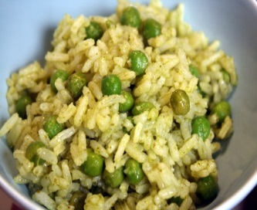 rice & peas or chow mein
Served with provision salad, green salad
provision salad & green salad 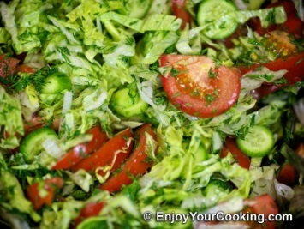 fried fish $15.00 or
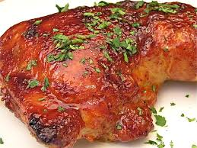oven baked chicken $10.00
Please call our office on 444-5100 to place orders, delivery available
Thank you for your support!

