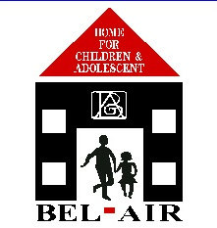

Bel Air Home for Children & Adolescents Inc.

Annual Report

2016-2017

Introduction

Over the past twenty years Bel Air Home for Children and Adolescents Inc. has been providing a safe, caring, loving and protected environment for children and young people 0-18 years, who have been deprived of their natural family setting.

The Child Protection Authority which is the Governing Body of the Home provides for the Protection of Children in Grenada under a legal framework.

The annual report of the company is published every year for its many contributors and members. The appended audited financial statements for 2016-2017 form an integral part of this report.

2.0 The Company
At the last annual meeting in February, 2017, there were
seven ordinary members of the Company including five
directors listed below.
The officers and Directors were re-elected in February 2017
until the next annual meeting. The officers are:-
President : Ms. Claudia Alexis
Vice-President: Mrs. Lauren E. Grey-Beliaeff M.B.E.
Treasurer: Mrs. Merle Byer
Secretary: Mrs. Lisa Charles
Directors: Sis. Francis Nelson, Mrs Marina Williams-
Johnson
Sister Francis-Nelson is appointed by the St. George’s
University.

The other members are:
Mrs. Elise Evans
Mr. Tim Byam
Mrs. Marina Williams-Johnson resigned in March, 2017.
3.0 Staff
The staff at the Home consists of a Management team which includes the Manager, Assistant Manager- Educational Needs Co-ordinator, Home Co-ordinator, an Administrative Assistant and four supervisors. There are also eleven caregivers who are rotated on a twenty-four hour shift basis.
The Board of Directors is pleased to place on record its appreciation to all the staff members who worked at Bel Air during the year under the guidance and direction of the Home Manager Mrs. Lisa Charles.

4.0 Residents
On 30th June 2017 there were 23 children, resident at Bel Air Home, 11 in the Nursery and 12 adolescent girls. During the year, there were 11 admissions and 10 discharges. Included in the admissions were 3 babies in the age range of one month to 9 months.
Our school age residents continue to show improvement in their academic studies. Our oldest boy sat the CPEA exams and was successful but has since been transferred. At the end of the financial year there were four girls attending secondary schools.
At the end of June 2017 there were nine ( 9) children in
primary school, one (1) in pre-primary and one (1) attending
a skills training center.
Congratulations to the successful children and particularly
to Ms. Alison Greene – Education Needs Co-ordinator, staff, and community volunteers who continue to assist
with their studies and homework.
Presently there are more children than normal at secondary schools and the home is therefore seeking to find a teacher and more volunteers to assist with homework, schools projects and other development needs.
5.0 Finance
The audited financial statements for the year July 1st 2016 to June 30th 2017 are attached to this report. Special thanks to Mr. Henry Joseph of Pannell Kerr Foster and his staff for continuing to undertake this task on a voluntary basis.
From January to September 2017 the Home was faced with a reduction in the Government’s subvention of over $4000.00 per month. This adversely affected the provision of care for the residents. Despite the many challenges it is heartening to note that the home was able to operate and manage its finances without much liquidity problems in the year.

6.0 Appreciation
The St. George’s University continued its generous contribution towards the running costs of the Home. The amount received for the period was EC$133,620.00. The University was responsible for purchasing the land on which the Home is built, and to date it continues its monthly financial support.
The Directors express their appreciation to the Trustees for the University’s continued support.

The Board also acknowledges the Government of Grenada’s subvention of EC$37,5713.00 received during the period under review, and although less than previous years the Directors sincerely thank the Government for its continued contribution without which the Home will struggle to exist.

Simon and Elizabeth Batey through The Friends of Bel Air (UK) contributed $47,554.00 towards the upgrading of the kitchen at the Home. We are indeed grateful for their continued support.
Grenlec over the years has been one of the Home’s main local contributors. It was through its initial donation of EC 1M dollars that the Home was built. In later years it was through its funding the pre-school and the nursery extension were constructed. We thank Grenlec also for its continued annual contribution towards the upkeep of the Home.
We thank the Chairman of Grenada Electricity Services Ltd. for his continuing financial contribution and interest in the Home.
There were also donations of food, clothing, household and other valuable items from local and overseas donors which went a long way in reducing the expenses during the year.
Visitors who visit the Home also assisted with other areas of need.
We will again wish to place on record our thanks and appreciation to the sponsors of the children and all other supporters and donors at home, the UK, Canada and the U.S.A for their continued support.
The Directors also thank the members of the local business community for the support provided during the period, both financially and in kind.
We thank NAWASA for its continued discount on the water consumption of the Home, Jonas Browne and Hubbard G’da Ltd for its donation of supermarket items throughout the year and Real Value Supermarket for contributions of food and other supermarket items and especially the donation of the proceeds from its Annual Fun Day activity.
We also thank Geo. F. Huggins & Co. Ltd., Island Style Tile and Bath and G & B Trading for their contributions.

7.0 Professional Services
The Directors are very grateful to Dr. Beverly Nelson, Dr. Jennifer Isaac, Dr. Doris Joseph, and CHORES for their medical services provided free of charge.
8.0 Volunteers
Volunteers continue to be associated with the Home, many of them are from the St. George’s University Students’ body.
These volunteers assist the children with homework, recreational activities and general care.
The Danish students also make very meaningful contributions towards the children’s welfare while they are on assignment here in Grenada. We thank them for their contributions and the administrators of UCC department of Social Education-Denmark for allowing the programme to be done in Grenada. We look forward to the partnership continuing.
8.1 Future Outlook
Bel Air Home with its limited funds will continue to make the best choices in managing its resources to enable it to maximize benefits for the children. As more children enter secondary schools the need for teachers and counsellors will increase. It is our hope that some of these can be met on a voluntary basis.
We value all contributions whether in cash or kind as we strive to make Bel Air Home a better place for all the children entrusted to our care.
Our best wishes are extended to all for 2018.

Gallery

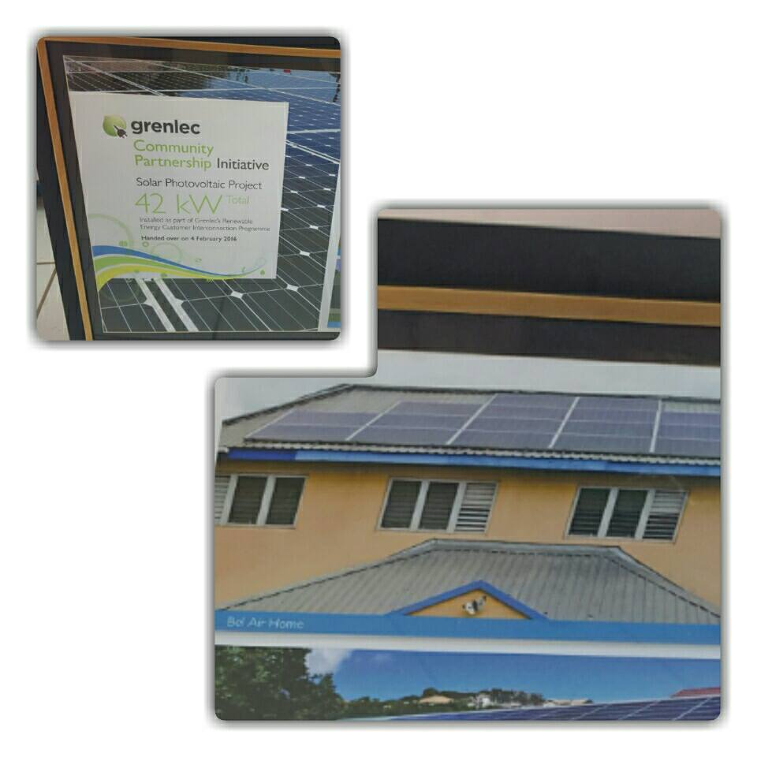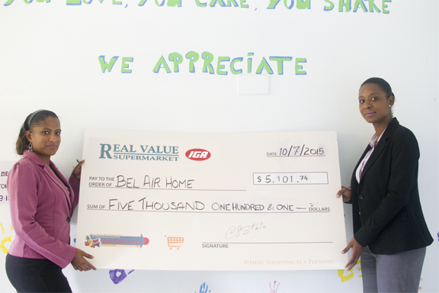
Grenlec solar panel donation Real value Donation
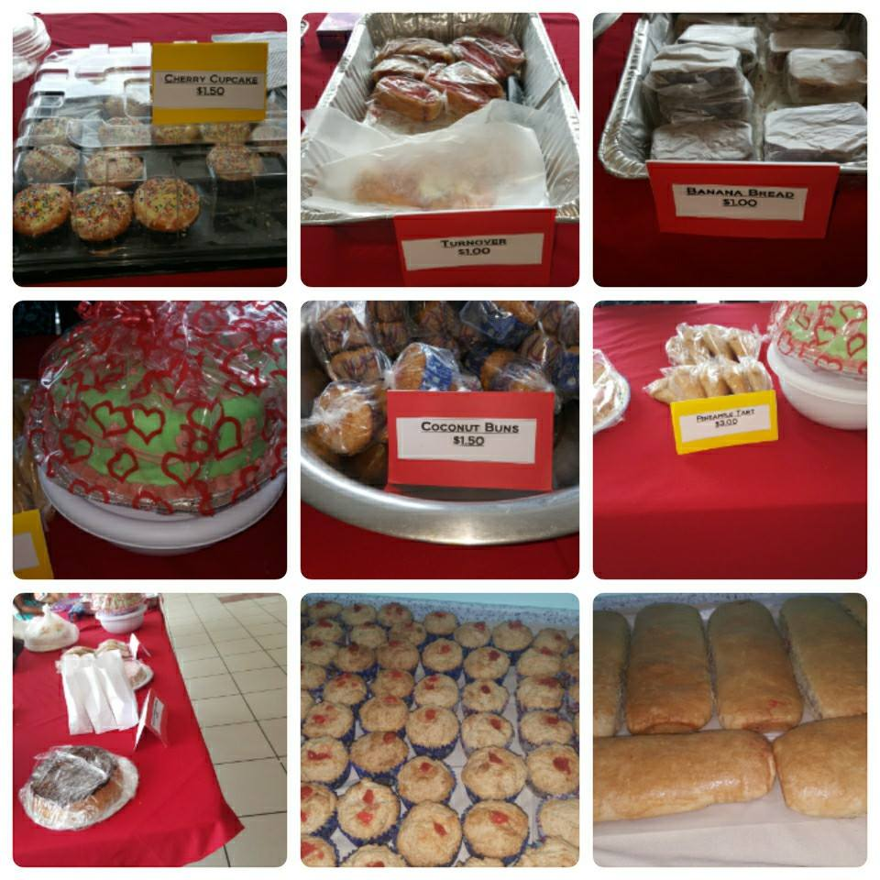
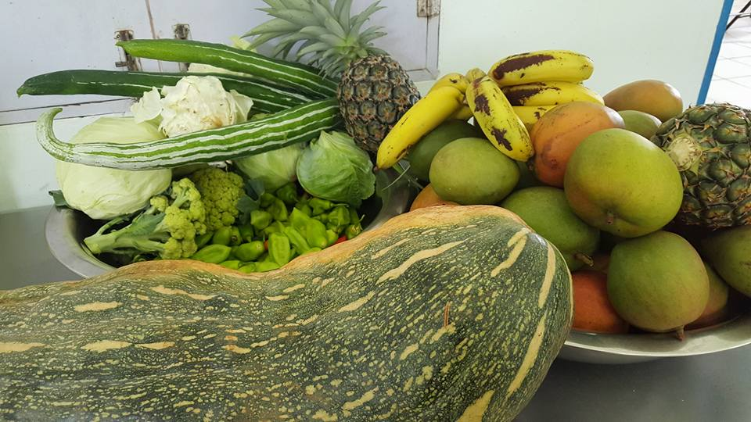

Donation of fruits and veggies by Fundraising Bake sale
Local farmer

BEACH FUN!!

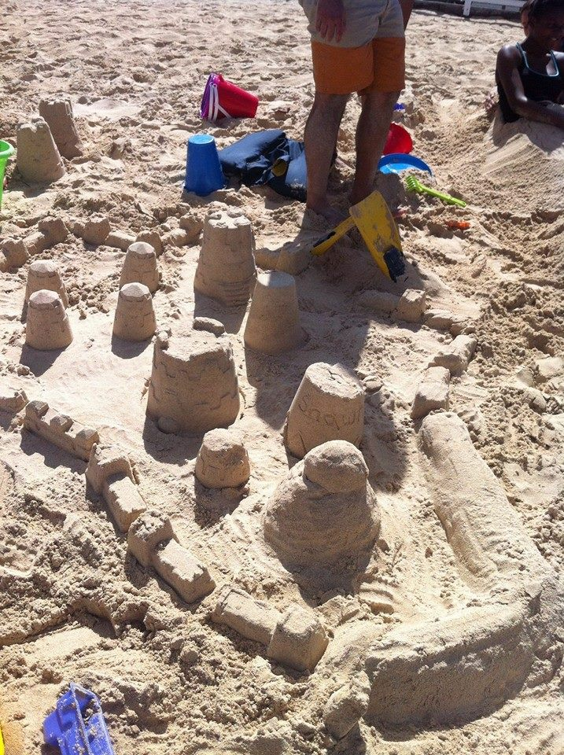
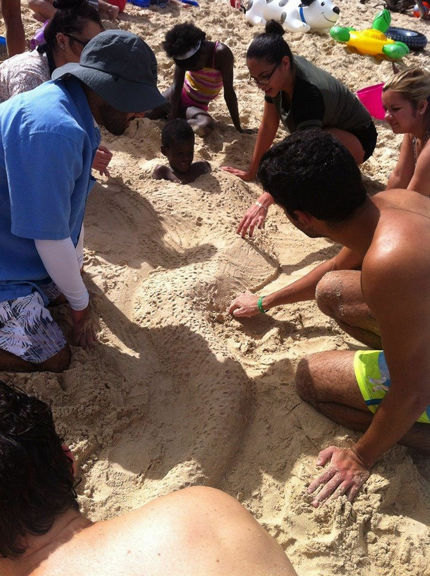

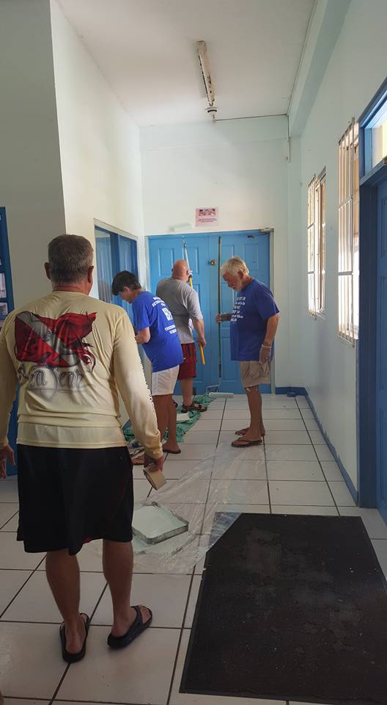
Christian Scuba Diving Association donated household items and their time, brightening the building.

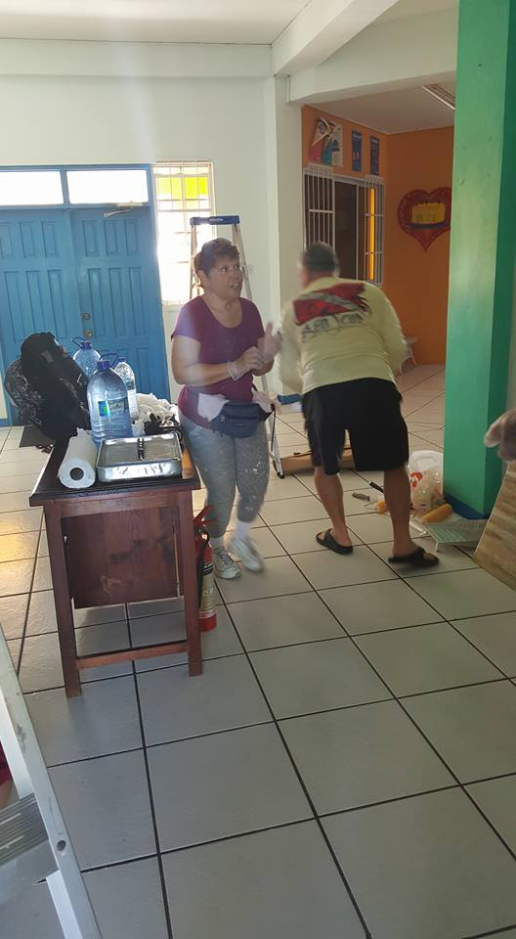

Catholic Hearts Work Camp donated their time and resources to beautify the building and surroundings

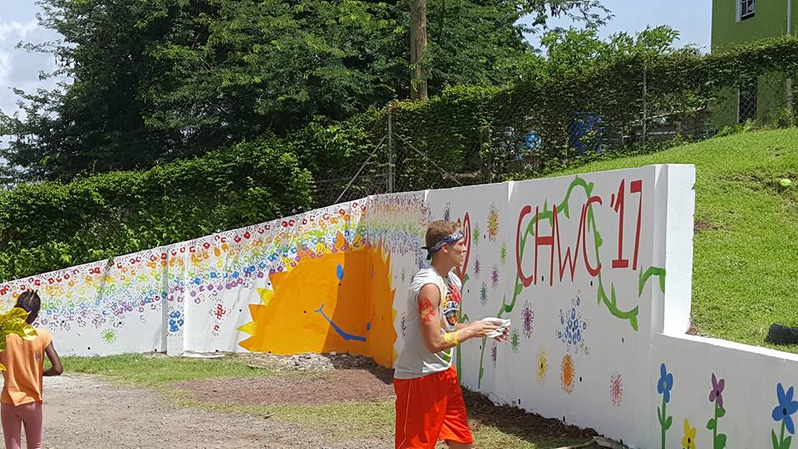
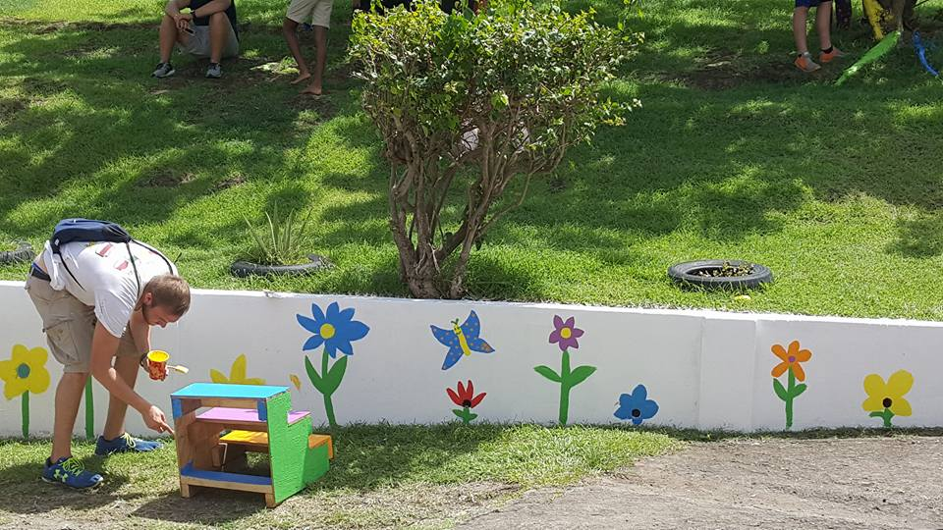
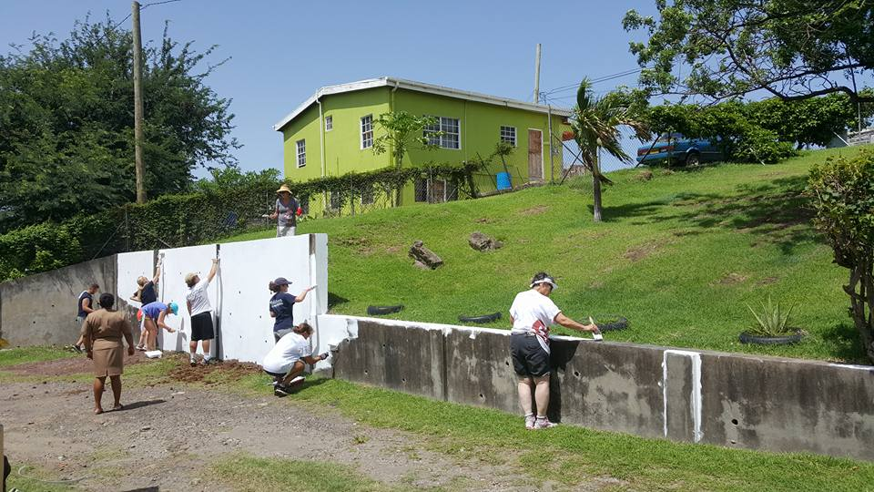
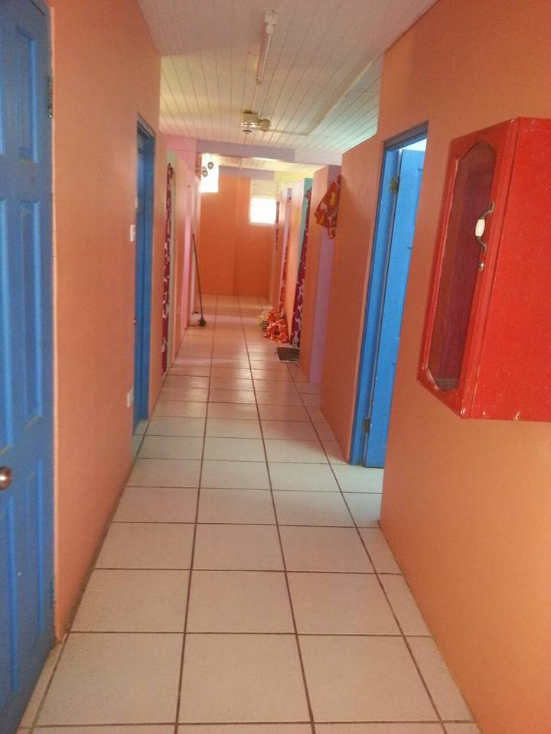

Activities and Art by the Residents
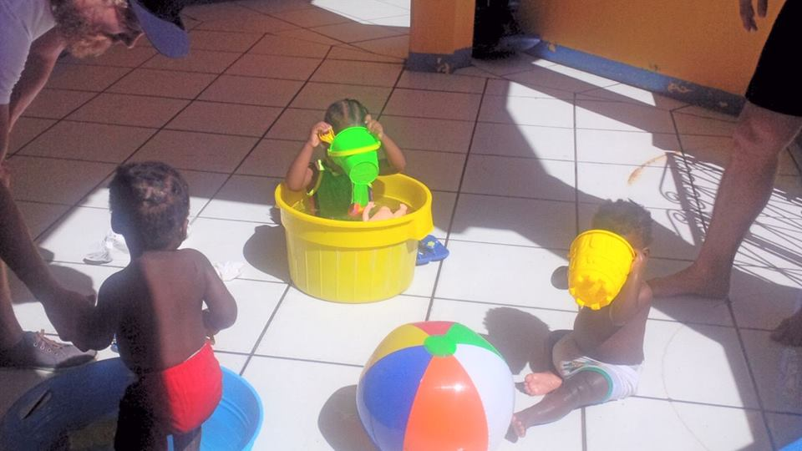

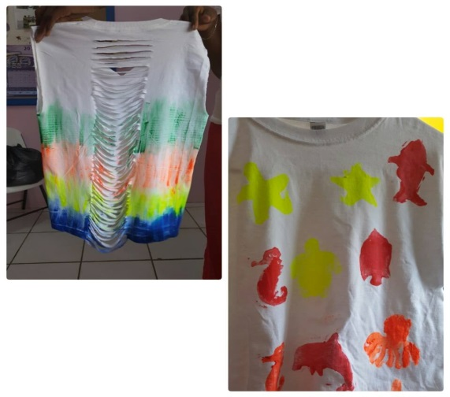
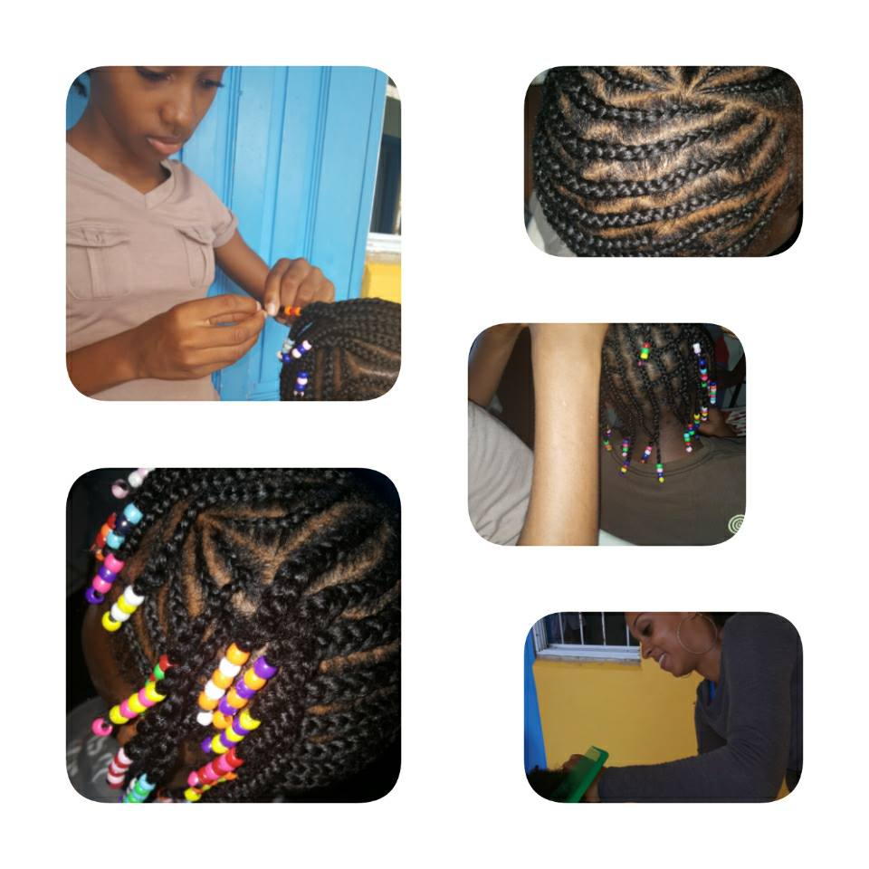

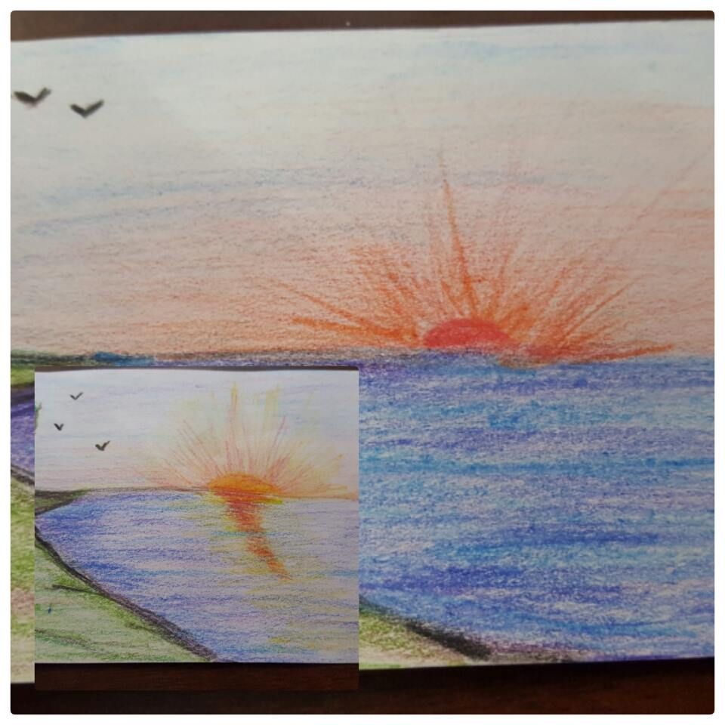
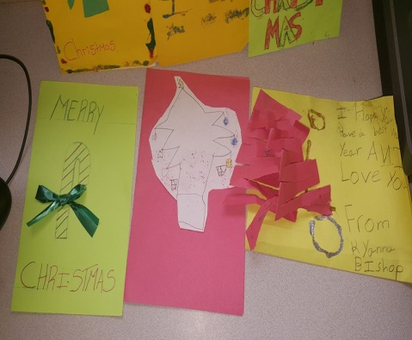
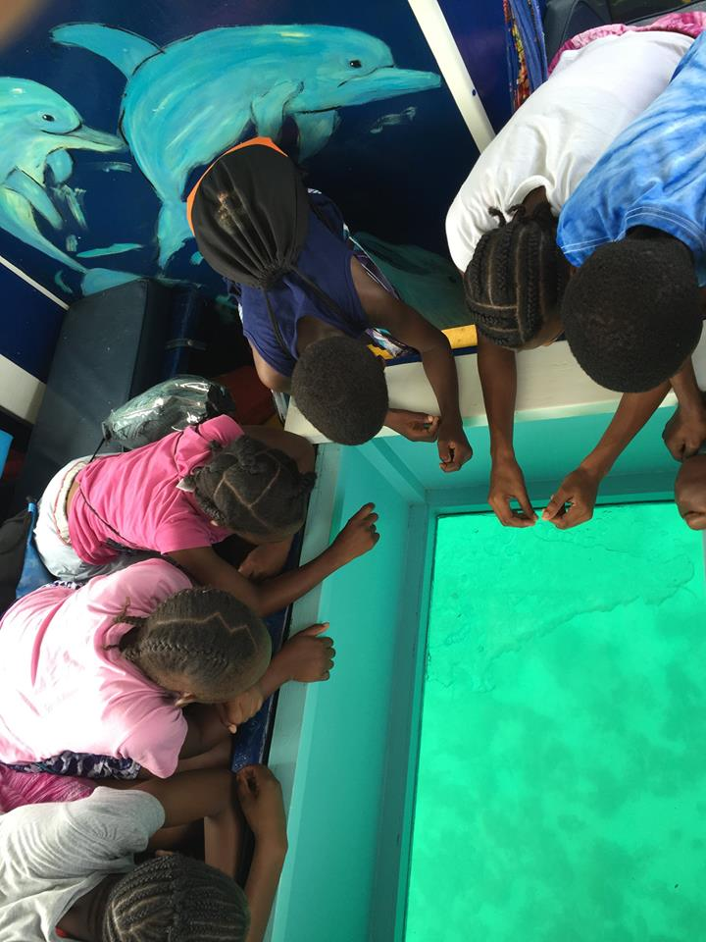
Christmas at Bel Air / Lunch provided by Mr. Ulrich Kuhun
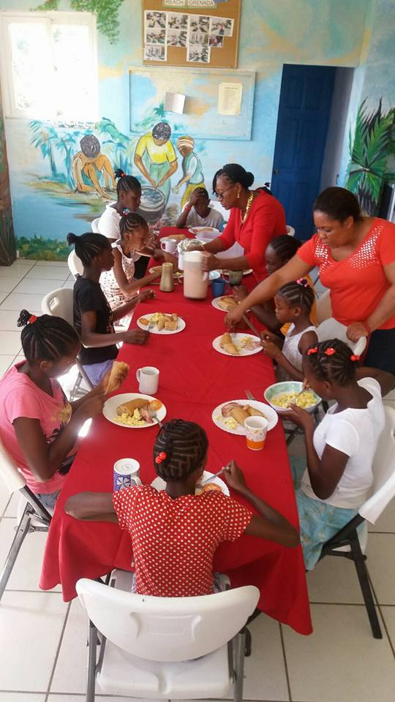
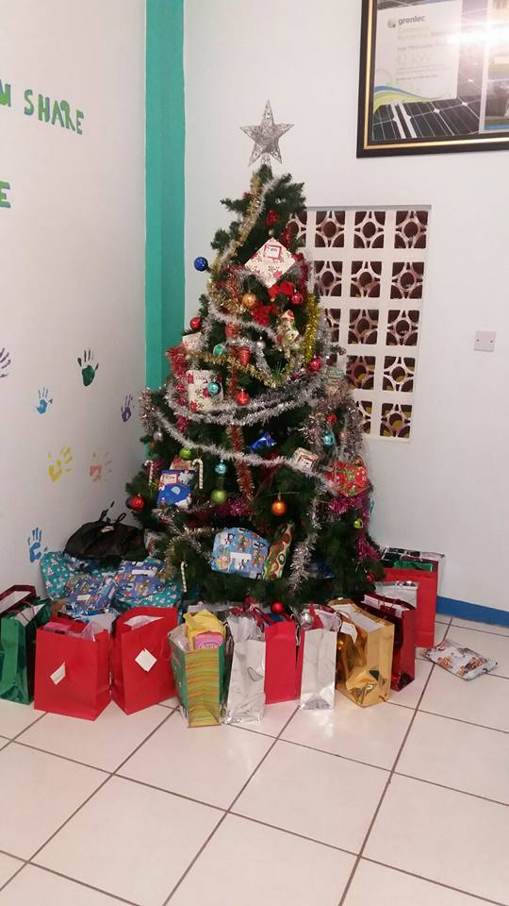
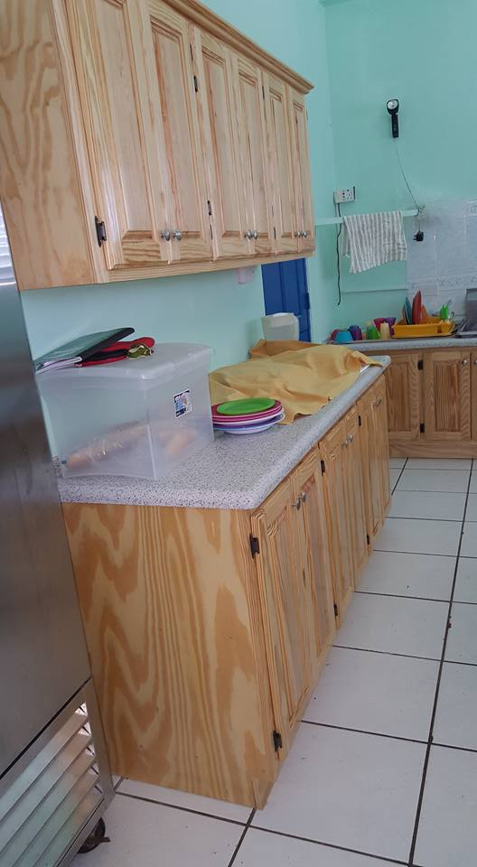

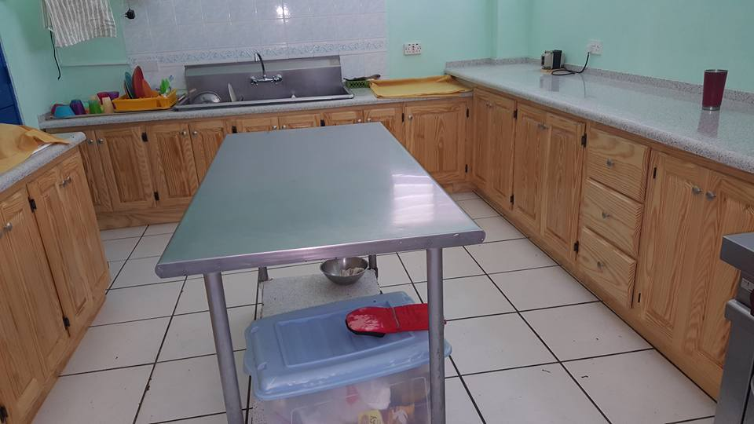
Kitchen Refurbishment

